

**‘A’ LEVEL GUIDE**

**AGRICULTURE**

Paper 2

1. *Using the same axis on a graph paper provided, draw the lactation curves for cow A and B. (08 marks)*

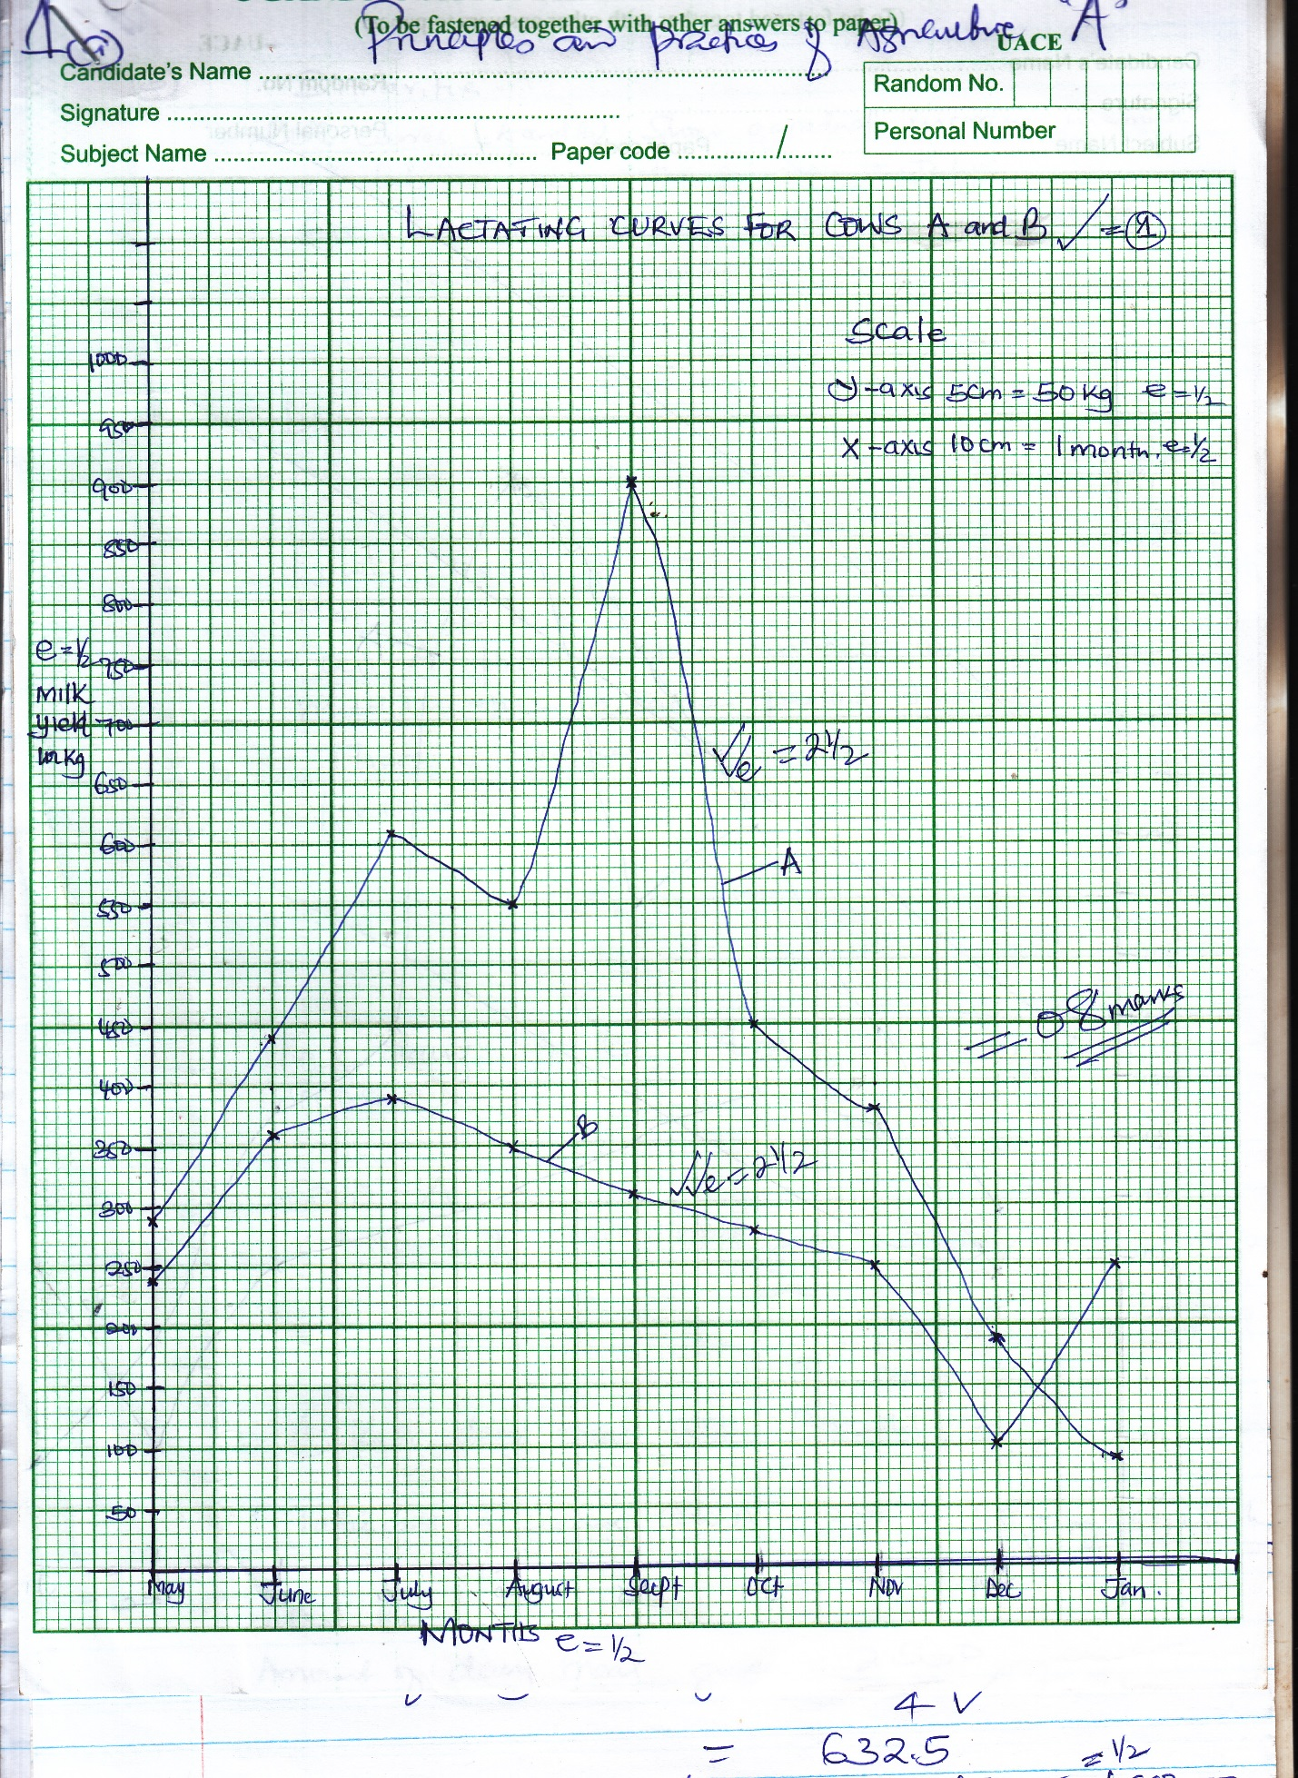

1. *Compare and contrast the lactation curve for A and B cows. (03 marks)*

***Similarities***

* *Both curves (A and b) show a gradual increase in milk yield between the months of May to July*
* *Both curves (A and B) show decline in yield between the months of September to December*
* *Both curves A and B show gradual decreased between July and August*
* *Both curves increase and decrease from May to August*

*1 x 1 = 1 mark*

***Differences***

* *The peak of milk yield for A is in September while that fro B is in July*
* *Lowest yield for cow A is in January while that for B is in December*
* *Cow A procures the highest amount of milk in the lactation period than B*
* *There is unexpected increase in milk yield for cow B between December and January*
* *There is a rapid increase in lactation curve of cow A and gradual decrease in lactation curve of cow B between August and September*

*Rej. Quickly / fast*

*Rej. Slowly*

*Gradual / stead slight*

*2 x 1 = 2 marks*

*1kg of dairy for each 4kg of milk*

*(3000 shs @) e = ½ mark*

*Cow A*

*Amount of dairy meal given =*

*= 975kg of dairy meal neede*

*@ kg of dairy meal costs 3000sh. = ½*

*Total cost of feeding cowa A = 3000 x 975 = 2,925,000/=*

*Cow B*

*Amount of dairy meal given =*

*= 6325 kge*

*Total cost of feeding cow A = 3000 x 632.5 e=* ***1,897,500***

*Returns from each cow*

*Cost of feeding cow A is 2,925,000 /=*

*Cost of feeding cow B is 1,897,5000/=*

*Value of milk produced by cow A = 2000 x 39080 e = ½*

*= 7,800,000e = ½*

*Returns from cow A = 7,800,000 - 2,925,000 e = ½*

*= 4,875,000 e = ½*

*Returns from cow B = 2000 x 2530 e = ½ = 5,060,000/=e*

*= 5,060,000 - 1,897,500/= e = ½*

*= 3,162,500 e = ½*

***SECTION B***

***CROP PRODUCTION (20 MARKS)***

1. *(a) Describe the various structures found in soils. (08 marks)*

* *Crumby / crumb structure - its made up of small, soft and porous aggregates of irregular shape*
* *Granular structure – soil aggregates are circular in shape and loosely arranged*
* *Blocky structure – aggregates in this structure are arranged rectangular blocks that fit together*
* *Prismatic structure – soil particles are arranged vertically to form pillar shaped aggregates*
* *Platy structure - aggregates in this structure are arranged on top of one another in relatively twin sheets*
* *Columnar structure – pillar shaped aggregates with round tops*

*Any 4 points ½ mention*

*1 ½ explanation*

*4 x 2 = 8 marks*

*(b) How does soil structure influence crop growth and yield? (08 marks)*

* *A good soil structure ensures retention of plant nutrients for crop growth hence high yield*
* *A good soil structure proper retention of soil moisture necessary for good crop yields*
* *Proper soil structure ensures good soil aeration hence proper crop root growth*
* *Good structure ensures proper water percolation hence good soil drainage*
* *Good soil structure ensures proper heat distribution and enhancing activities of soil living organisms*
* *Good structure resists soil erosion hence conserving soil fertility*
* *Enhances availability of micro – organisms in the soil which carry out organic matte decomposition.*
* *Root penetration and development especially in the growth of tuber*

*Any 4 points well explained 2 marks @*

*4 x 2 = 8 marks*

*(c) State the ways of maintaining a good soil structure. (04 marks)*

* *Minimum cultivation - mulching*
* *Application of manures*
* *Planting vegetation / bush fallowing*
* *Improving soil drainage*
* *Controlling soil erosioin*

*Any 4 points 1 mark @ 4 x 1 = 4 marks*

1. *(a) What is the main difference between hay and silage? (02 marks)*

*Silage is* ***dried***  *forage fed to animals while silage is* ***fermented***  *forage that can be fed to animals. 2 marks*

*(b) Describe the procedure of making hay on the farm. (14 marks)*

* *Selection of a good crop for making hay*
* *Cut the crop at ground level using a panga / sickle*
* *Spread the crop evenly on the ground under a shade to dry*
* *Keep on turning the crop as it dries to make sure that it is drying evenly*
* *Allow the crop to dry for 3 days making sure that it retains original colour and leaves*
* *Test whether the crop is completely dry by twisting the stems*
* *Chop the crop into small pieces to make it easy for compacting in a box*
* *Prepare a bailing box with the dimensions of the hay bales required*
* *Place two strigs at each end of the bailing box to make bailing easy*
* *Compress hay to make compact cube in the box*
* *Tie the bales tightly with the string and then the box upside down to remove the bale.*
* *Store the hay in a shed to protect it from dust, rain and direct sunlight*
* *Sprinkle molasses or salty water on hay during feeding to increase palatability*

*First 12 points in order 1 mark @ 12 x 1 = 2 marks*

*(c) State the advantages of conserving pastures. (04 marks)*

* *Reduces wastage of pasture during periods of plenty*
* *Allows for proper feeding of animals even during perods of scarcity*
* *Ensures continuous good animal production in terms of product throughout the year*
* *Increases number of animal kept per unit area of land*
* *Ensures proper utilization of pastures by livestock*
* *Pastures can be easily sold to get extra income*
* *It enables planned feeding practices in livestock*
* *Makes keeping of feeding records for livestock easy.*

*Any 6 points 1 mark @ 6 x 1 = 6 mark*

***SECTION C***

***ANIMAL PRODUCTION (20 MARKS)***

1. *(a) What is the difference between a hive and an apiary? (02 marks)*

*A hive is a house for bees / where bees live while an apiary is a collection of bee hives in a particular place / a place where bee hives are laid*

*(b) Give the characteristics of a good Apiary and Hive. (08 marks)*

*Characteristics of a good apiary*

* *Should be free from noise / away from noisy area*
* *Should be well protected from strong winds*
* *Should have enough shade for hives*
* *Should be near a good water source*
* *Should be free from predators*
* *Should be free from flooding*
* *Should be near nectar sources / flowering plants*

*Any 5 points 1 mark@ 5 x 1 = 5marks*

*Characteristics of a good hive*

* *Should have enough entries to allow access by bees*
* *Should be well ventilated*
* *Should be big enough*
* *Should have a queen excluder for queen protection*
* *Should a removable lid for easy hive inspection*
* *Should be leak proof*
* *Should have handles for easy carrying / loop for hive suspension*

*Any 3 points 1 mark @ 3 x 1 3 marks*

*(c) (i) Describe the procedure of harvesting honey from a hive. (08 marks)*

* *Put on protective clothes and carry a lighted smoker, honey container with a lid, bee brush and hive tool*
* *Approach the hive quietly from behind to avoid disturbing the bees*
* *Blow smoke around the hive 3 times to make the bees inactive*
* *Lower the hive to a comfortable position so as to be able to inspect the combs befreo harvesting them.*
* *Lift the top bars and brush off the bees with a bee brush*
* *Cut the mature and ripe combs which are fully capped with honey to leave about 3cm of wax on the top bars*
* *Drop the cut combs into the harvesting container and cover*
* *Place back the bars and do not disturb the brood*
* *Cover the hive and place it back into position*

*Any 8 in order 1 mark @ 8 x 1 = 8 marks*

*(ii) State the products that can be got from the hive. (02 marks)*

* *Bee venom*
* *Wax*
* *Brood*
* *Honey*
* *Propolis*
* *Pollen*

1. *(a) What is brooding as used in poultry management? (01 mark)*

*This is the care and management of young chicks up to the stage of six weeks*

*(b) How should a farmer manage chicks in a brooder? (09 marks)*

* *Clean and disinfect the poultry house thoroughly to kill pathogens for pests*
* *Install all necessary equipment to be used in a brooder*
* *Prepare and install a water bath at the entrance of the house to ensure good hygiene for people entering the house*
* *Seal of all crevices and small entrances into the house to keep out rodents that can eat the chicks*
* *Place curtains in the window to air flow into the house so as to be able to maintain temperature*
* *Light up the heat source to provide warmth in the brooder*
* *Install brooder guards around the heat source that act as an enclosure for chicks*
* *Provide a thin layer of mouldfreee lither in the brooder and cover it with clean paper to stop chicks from eating litter*
* *Hung a thermometer in the brooder guards to monitor the brooder temperatures at optimum*
* *Put clean feeders around the heat source like spokes of a when where the chicks are to feed from.*
* *Provide enough drinkers at a ratio of 3 to every 100 chicks to control crowding at the drinking place.*
* *Isolate sick chicks to avoid disease spread*

*9 points 1 mark @ = 9 x 1 = 9marks*

*(c) (i) Why should a farmer invest in a poultry enterprise rather than a dairy enterprise? (05 marks)*

* *The initial cost of start poultry is lower than that of a dairy enterprise*
* *Poultry take a short period to bring in returns as compared to dairy*
* *Poultry provides many areas of specialization than the dairy enterprise*
* *Poultry products richer in terms of nutrients than dairy*
* *Eggs from poultry are less perishable as compared to milk from dairy*
* *Dairy products are easy to adulterate as compared to poultry products*
* *Poultry are highly prolific than the dairy animals*
* *Poultry products are much more marketable than dairy products*
* *Poultry requires a smaller piece than dairy ie. land for growing pastures.*

*Any 4 points 1 ½ mark @ 4 x 1 ½ = 6 mark*

*(ii) State the causes of mortality among chicks kept in a brooder.*

*(05 marks)*

* *Disease like gumboro*
* *Pest attack*
* *Harsh temperatures*
* *Physical injuries*
* *Drowning in big drinkers*
* *Suffocation due to over crowding in corners*
* *Poor feeding*
* *Poor ventilation leading to respiration infection*
* *Being burnt by the source of heat*

*Any 4 points 1 mark @ 4 x 1 = 4 marks*

***SECTION D***

***FARM MECHANIZATION AND FARM STRUCTURES***

1. *(a) Give the various ways of maintaining farm tools and equipment in a good*

*working condition. (06 marks)*

* *Washing some after use to reduce corrosion between agro – chemicals and equipment*
* *Regular sharpening cutting edges / blades / teeth to ensure efficiency*
* *Oiling / greasing moving parts to control friction*
* *Painting of metallic parts to control rusting*
* *Tightening lose bolts and nuts to ensure efficiency*
* *Store the tools equipment in a cool dry place to control rusting of metallic parts and breaking or cracking of wooden parts*
* *Replace broken handles or parts to ensure efficiency of machines.*
* *Use the tool or equipment always for the designed purpose to reduce damage*
* *Unblock the nozzles of sprayers to reduce damages due to pressure*
* *Oil / grease tools when not in use to reduce rusting*

*Any 6 x 1 = 6 marks*

*(b) Explain the factors considered while selecting farm tools and equipment for use in the farm. (14 marks)*

* *Cost of the tool or equipment*
* *Most farmers prefere cheap tools*
* *The machine should do the work it is meant to do*
* *Buy machines that require less skills to use*
* *Buy machines that are highly durable*
* *Buy machines that are effective*
* *Cheap to maintain.*
* *Buy efficient machines*
* *Should be available*
* *Work to be done*
* *Skills of using it*
* *Durability of the tool or equipment*
* *Effectiveness of the tool or equipment*
* *Maintenance cost of the tool or equipment*
* *Work out put of the tool or machine or efficiency of tool or machine*
* *Availability of tool or equipment*
* *Availability of spare parts*
* *Versatile tools having many uses.*

*Any 7 points 1 mark mention, 1 mark explanation*

1. *(a) Describe the procedure of constructing a fish pond. (12 marks)*

* *Select a suitable site pond construction*
* *Survey the land by marking out the slope and find out the natural drainage pattern of the area*
* *Clear the site of stones, tree stumps and roots that can interfere with harvests of fish*
* *Clear the trees around the site to allow the ponds to get enough light*
* *Mark out the area where the pond and walls to be constructed with pegs*
* *Dig out the soil from the marked area while separating top soil from subsoil*
* *Make the depth of the pond between 1 . 0 – 1.5 meters for easy harvesting of fish*
* *Create inlet and outlet for the pond to allow exchange of pond water*
* *Use the sub soil to build pond walls by compacting soil as you pile it around the banks to make a farm, stable and leak proof walls*
* *Fix inlet and outlet pipes within walls to allow water to move in and out of the pond respectively*
* *Place another pipe above the wall to drain away excess water and to prevent flooding and spillage of water from the walls*
* *Spread the top soil that was earlier put aside over the pond walls and plant the walls with grass to prevent wall erosion*
* *Spread a layer of lime on the pond floor about 15 days before filling the pond with water to encourage growth of plytoplankton*
* *Fill the pond with clean water slowly to reduce scouring of the walls / destruction*

*1 mark @ 12 points 1 mark @ 12 x 1 = 12 marks*

*(b) State the various management practices carried out on a fish pond to maintain it in a good condition. (08 marks)*

* *Plant grass along the walls for stability and controlling wall erosion*
* *Fence off the pond to keep away animals that may danger the pond walls*
* *Construct diversion channels around the pond to direct rain water away from the pond to avoid flooding*
* *Trim tree roots to prevent it from breaking pond walls*
* *Plant weeds in the pond to provide oxygen and shelter to fish during dry period*
* *Re – d silt the pond regularly to maintain depth*
* *Drain out exhausted water regularly and refill pond with fresh water*
* *Lime the pond regularly tomaintain the pH of water between 6.5 – 9.0*
* *Fertilize the pond to ensure fish feed is enough.*
* *Control algal bloom by minimizing water pollution by fertilizers or manures*
* *Control fish predators like birds regularly by putting a net over the pond.*

*Any 8 points 1 mark @ 8 x 1 = 8 marks*

***SECTION E***

***ECONOMICS AND FARM MANAGEMENT***

1. *(a) Distinguish between price elasticity of demand and shift of demand curve.*

*(02 marks)*

*Price elasticity of demand is the degree of responsiveness of change in quantity demanded due to a change in price while a shift in demand is the movement of the demand curve either right or left from original at a constant price.*

*(b) Explain the factors that can cause a shift in demand curve at a constant price.*

*(08 marks)*

* *Change in income of consumers at constant price will cause a shift in demand*
* *Change of tastes and preferences of consumers causes a shift in demand curve*
* *Change in culture of saving by consumers cause a shift of demand curve*
* *Change in the number of consumers of an item causes a shift at constant price*
* *Speculation about future prices can cause a shift in demand either positively or negatively*
* *Advertisement levels will affect demand either positively or negatively by causing a shift in demand*
* *Inflation can cause a shift of demand curve either away depending on level of prices*
* *Quality of products sold can cause a change in demand hence shift as it changes*
* *State of the economy where by a booming economy causes demand curve to shift right as demand increases.*

*Any 4 points 1 mentioned 1 expln.*

*4 x 2 = 8 marks*

*(c) State the various steps that farmers should take to ensure high profitability*

*of farm business. (10 marks)*

* *Choose highly profitable business*
* *Advertising the produce to attract potential buyers*
* *Sell produce when prices are high*
* *Timely planting of crops to ensure high yields*
* *Use improved breeds of livestock for varieties of crops*
* *Process agriculture products to add value*
* *Grade products for easy pricing*
* *Pack products to reduce transport costs*
* *Control of pests and diseases to ensure high quality*
* *Proper resource allocation to reduce prices*
* *Proper branding of products for high prices*
* *Using high technology in production / using skilled labour*
* *Input rationing to ensure less costs of production.*

*Any 10 points 1 mark @ 10 x 1 = 10 marks*

1. *(a) Explain the importance of carrying out land reforms in Uganda. (12 marks)*

* *To achieve high levels of land output by increasing investment*
* *Increase land productivity through intensive farming*
* *To encourage production for the market which is highly profitable*
* *Encourage land conservation by gazeting conservation areas*
* *Reduce land conflicts through registration of land*
* *To resettle land less people in land*
* *To make supervision of agriculture activities through land consolidation*
* *Reducing idle land and increases land productivity through redistribution of land*
* *To encourage large scale farming through land consolidation*
* *To increase access to land as a factor of production through land redistribution and registration*
* *To increase investment in agricultural by providing enough land and for farming.*

*Any 7 points 2 marks 7 x 2 = 14 marks*

*(b) How can a farmer get land for agriculture in Uganda? (08 marks)*

* *Buying land from owners*
* *Renting land for use*
* *Leasing land from owners*
* *Being given land as a gift*
* *Being resettled on land by authorities*
* *Compulsory land acquisition by government*
* *Being given land as inheritance*
* *Contract agreement in usage of land*

*Any 6 points 1 mark @ 6 x 1 = 6 marks*

***END***